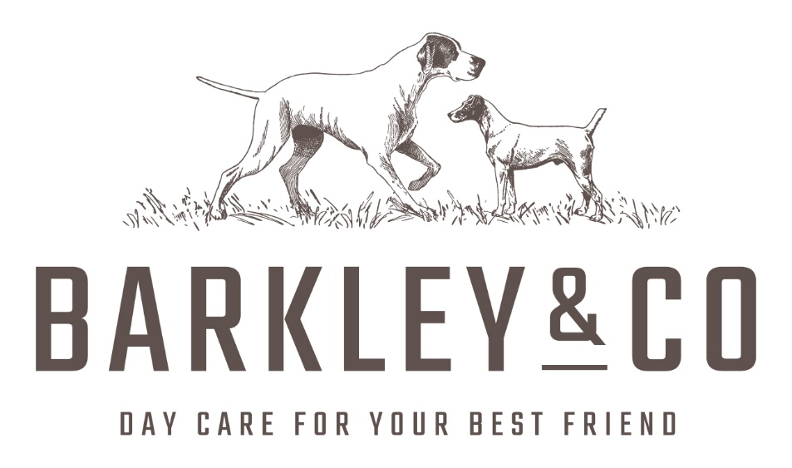

DOG DAYCARE APPLICATION FORM
PLEASE COMPLETE ALL THE INFORMATION REQUIRED

Where did you hear about us?
Owner Information
Title- | Forename- |  | Surname-
Email Address-

Mobile Number- |  | Work Number-
Home Address-

Spouse/ Partner Information
Title- | Forename- |  | Surname-
Email Address-

Mobile Number |  | Work Number-

Emergency Contact Information
Title- | Forename- |  | Surname-
Email Address-

Mobile Number |  | Work Number-

Dog Information
Name- | Breed- |  | Sex-
Birthday- |  | Age-
Spayed/ Neutered- |  | Colour-
Tagged/ Micro Chipped-

Codeword :
A codeword is used to ensure safe collection of your dog to the right person if you are not the person collecting them for any reason.

Veterinarian Information
Vet Practice-

Telephone Number-

Address-

Is your dog insured? (Please circle) YES NO

If yes, please detail who with below:
_________________________________________________________

Dog & Medical Health (If yes, please complete)
 | Date Received | Date Due
Kennel Cough
5IN1 (DHPPV, Distemper, Panvo etc)
Flea/ Worm Treatment
Any Medical Conditions? Please specify (e.g. hip/joints, heart seizures- please indicate any information offered by the vet. Please specify if your dog has had any recent surgery that may affect their time here at Barkley&Co. Any phobias or sensitive areas?)

YES / NO

Please give detail if YES:

Recent/ Current Injuries?

YES/ NO

Please give detail if YES:

Does your dog take any medication?

YES/ NO

Please give detail if YES:

Does your dog have any allergies?

YES/ NO

Please give detail if YES:

Dog Behaviour
Where does your dog spend most of their days?

Is your dog allowed on your furniture / bed at home?

Number of walks per day?

Average length of walk?

Do you walk your dog on a lead?

How many times is your dog fed per day?

Are you happy with treats to be given at day care?

Has your dog ever:
Reacted negatively around food/ toys etc? YES NO
Escaped from your property? YES NO
Growled at someone? YES NO
Bitten someone? YES NO

If you answered YES to any of the above questions, please give detail below

Socialisation
Does your dog enjoy playing with other dogs?

How often does your dog socialise?

How does your dog react to other dogs on a lead?

How does your dog react to dogs off a lead?

Has your dog had any formal training?
(If yes, please give detail, who with and what level)

Pet Service/ Products Used
Have you used a day care centre before?
(If yes, which one?)

Have you used a groomer before?
(If yes, which one?)

Has your dog had a bad experience with any of the above?
(If yes, please give detail)

Food
Please specify if your dog is allergic to any kind of food/ treats below:

Dry/ Biscuits (Please specify the brand you feed your dog)

Wet/ Tinned (Please specify the brand you feed your dog)

Raw (Please specify the brand you feed your dog)

Treats (Please specify the brand you feed your dog)

Other (Please specify the brand you feed your dog)

Will your dog be due a meal at day care? If yes, please give details of time. You will need to provide a daily portion at each visit

Barkley & Co Daycare Centre Terms & Conditions
I understand that I am solely responsible for any and all harm caused by my dog whilst my dog is attending Barkley & Co Daycare Centre.

I further understand and agree that in admitting my dog that Barkley & Co Daycare Centre has relied on my representation that my dog is in good health and has not harmed or shown aggression or threatening behaviour towards any person or any other dog.

I understand that during normal dog play, owners’ dogs may sustain injuries. All dog play is carefully monitored at Barkley & Co Daycare Centre to avoid injury, but scratches, punctures, torn ligaments, may occur despite the best supervision.

I further understand that Barkley & Co Daycare Centre is a sociable environment where animals are in groups and that at the Centre or on walks, I am responsible for the medical treatment or any injuries or illness that my dog may receive whilst at Barkley & Co Daycare Centre. I agree to pay all veterinarian care and costs if any injury or illness occurs at Barkley & Co Daycare Centre.

I agree to provide proof of current vaccinations or if my dogs vaccinations are found to be expired or otherwise incomplete Barkley & Co Daycare Centre has the right to refuse service until proof of current information is provided.

I further understand and agree that any behaviour or health problems that develop with my dog will be treated as deemed best by my staff of Barkley & Co Daycare Centre. I therefore assume full financial responsibility for any and all expenses involved. If my dog is taken for emergency treatment to the vets, I will be contacted to settle the bill.

I further understand that my dog should be castrated (if over 6 months) or in order to enrol at Barkley & Co Daycare Centre. Unspayed bitches must never be bought when on heat.

I further agree to notify Barkley & Co Daycare Centre of any infections and of contagious disease that my dog has been exposed to or is affected by. Such disease and conditions included distemper, hepatitis, kennel cough, parvovirus, worms, lyme disease, flea’s infectious disease and intestinal parasites.

I fully understand that my dog is infected or has a contagious disease I will not be allowed to bring my dog to Barkley & Co Daycare Centre until the condition has been resolved.

All dogs should remain on the lead until they are inside the Daycare Centre.

I further understand and agree to all of the conditions set by Barkley & Co Daycare Centre and that this statement will remain in full force and effect between the parties until or otherwise amended.

Photographs may be taken of your dog / dogs while at Barkley & Co Daycare Centre. These photos may be used on social media on the website or in marketing. If you do not wish for photos of your dog/dogs to be used, please state on this form. Otherwise, by signing the enrolment form permission is granted.

I certify that I have read and understand the terms and conditions set forth in this service statement, the application form, including health forms, which are hereby incorporated in to the service statement by reference. I agree by the terms and condition and accept all terms and conditions and statements of this statement. I hereby release Barkley & Co Daycare Centre, their staff of any liability of any kind arising from my dog attending and participating at Barkley & Co Daycare Centre.

Signed : ……………………………………………………………………………..
Print Name …………………………………………………………………………..
Date: …………………………………………………………………………..

